Universidad Nacional de Colombia
Facultad de Ingeniería



Diseño Preliminar

Presentado por:
Daniel Mauricio Marquez Cruz
Christian Alejandro Sanabria Pinzon
Juliana Parra Caro
William David Pinilla Ocampo
David Alejandro Sepulveda Amaya

Asignatura:
Ingeniería de Software II

CRC Cards:
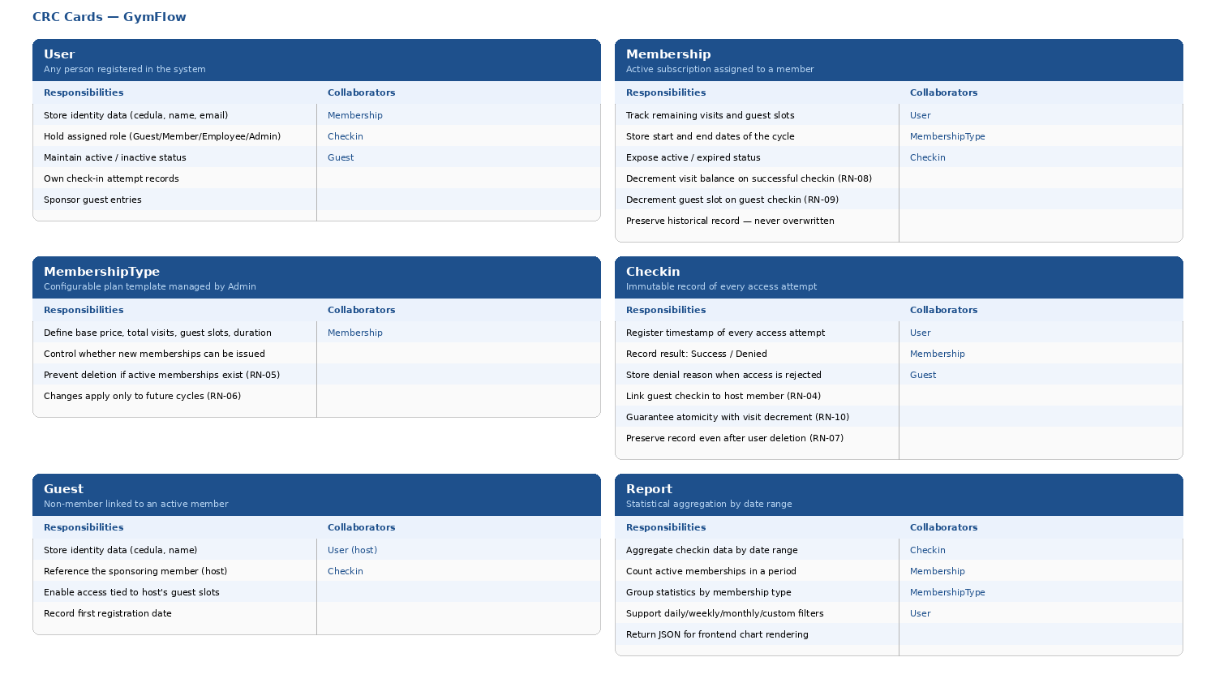

Mockups

Dashboard
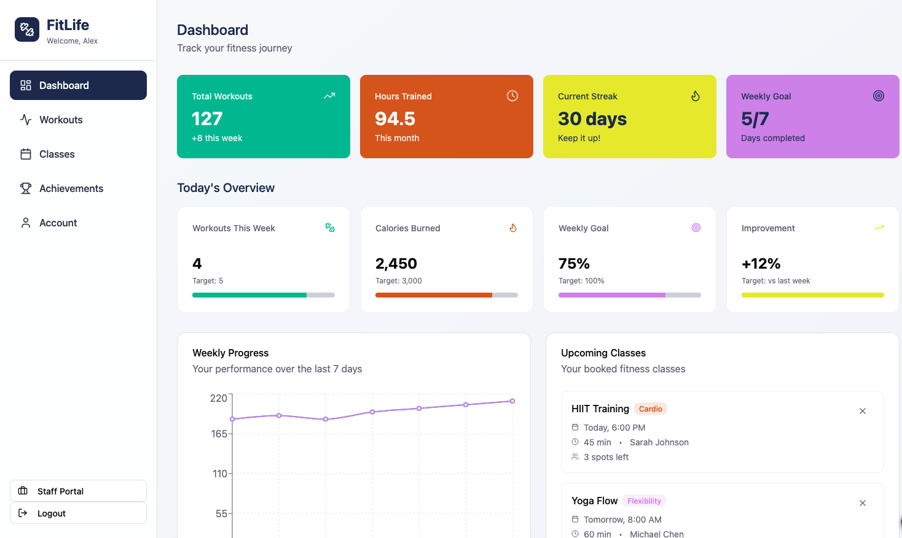

  - Entrenamientos
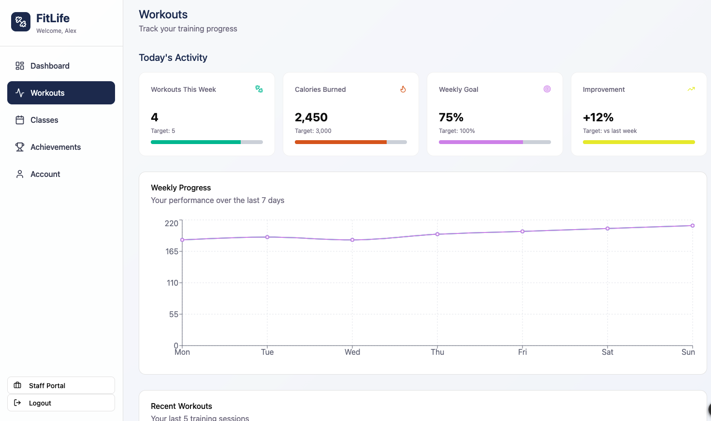
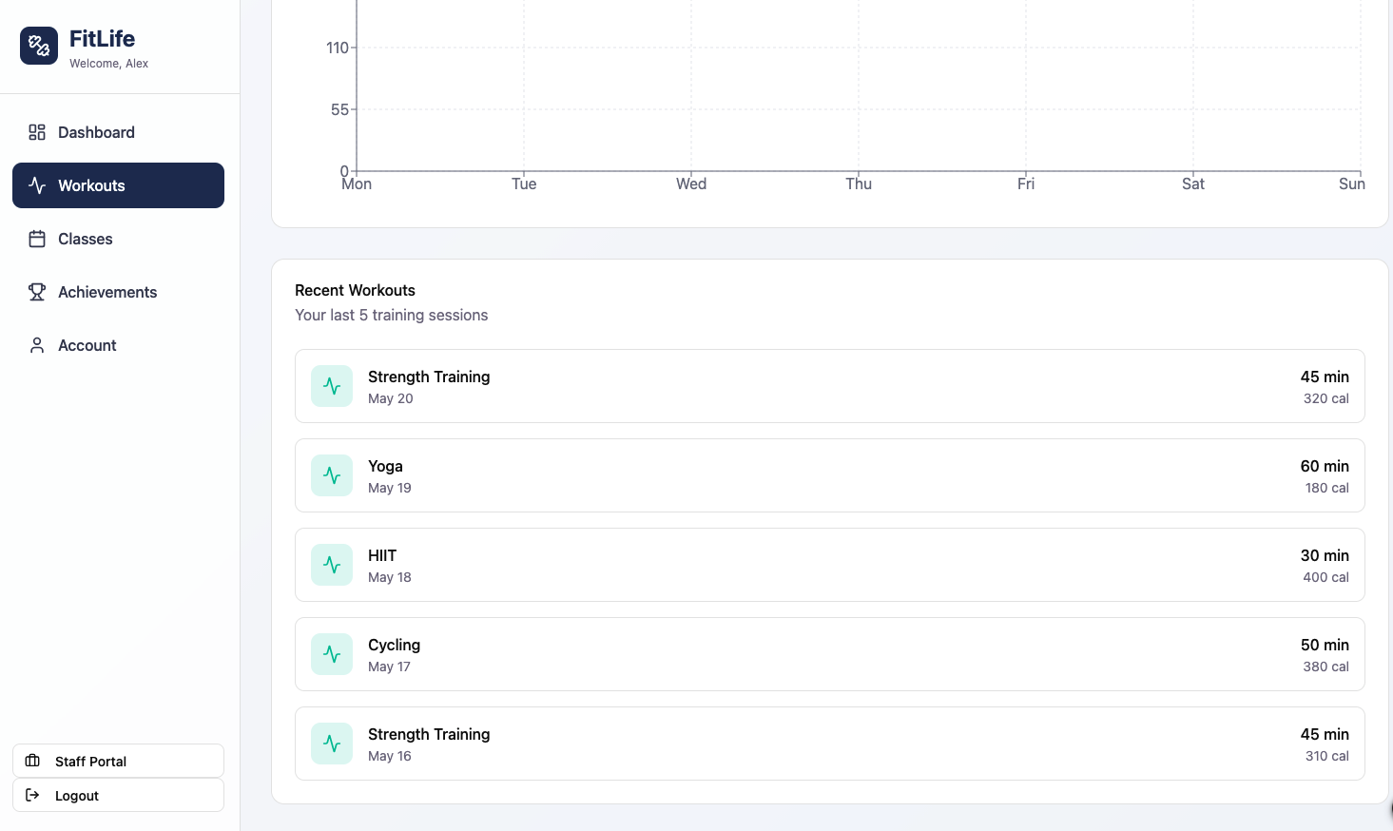

  - Clases

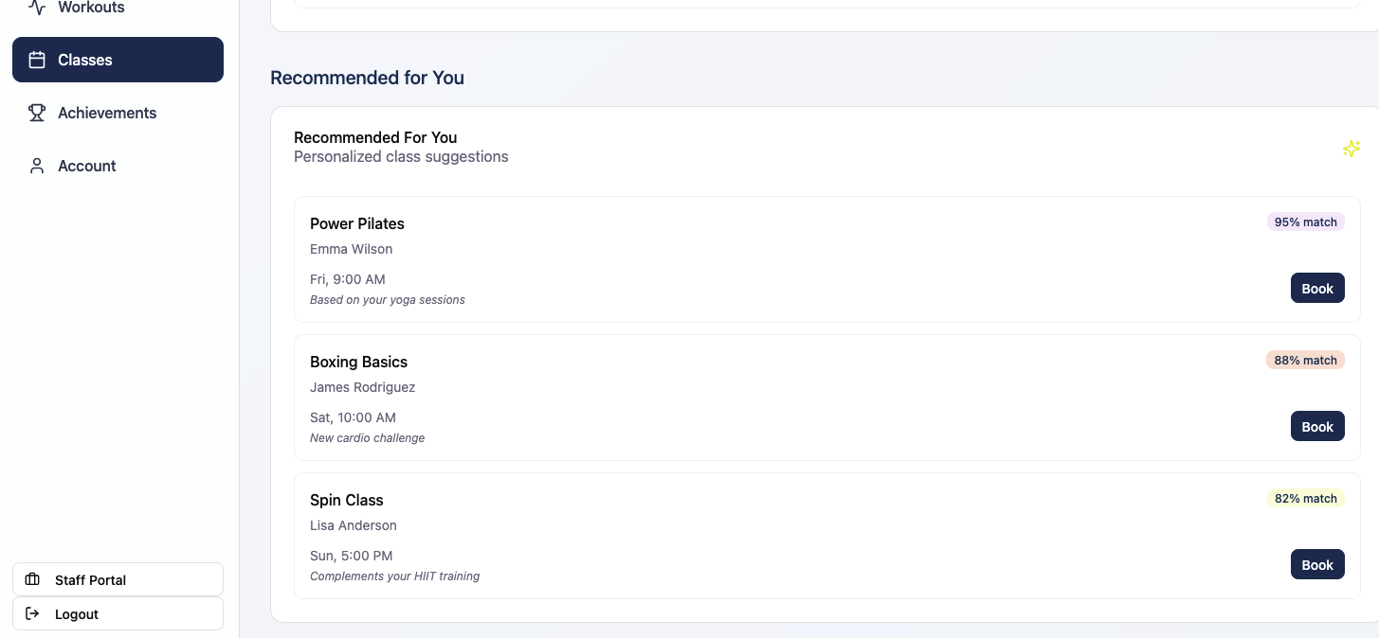

  - Logros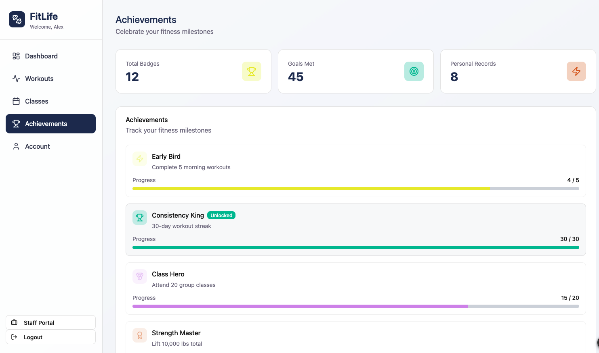

  - Cuenta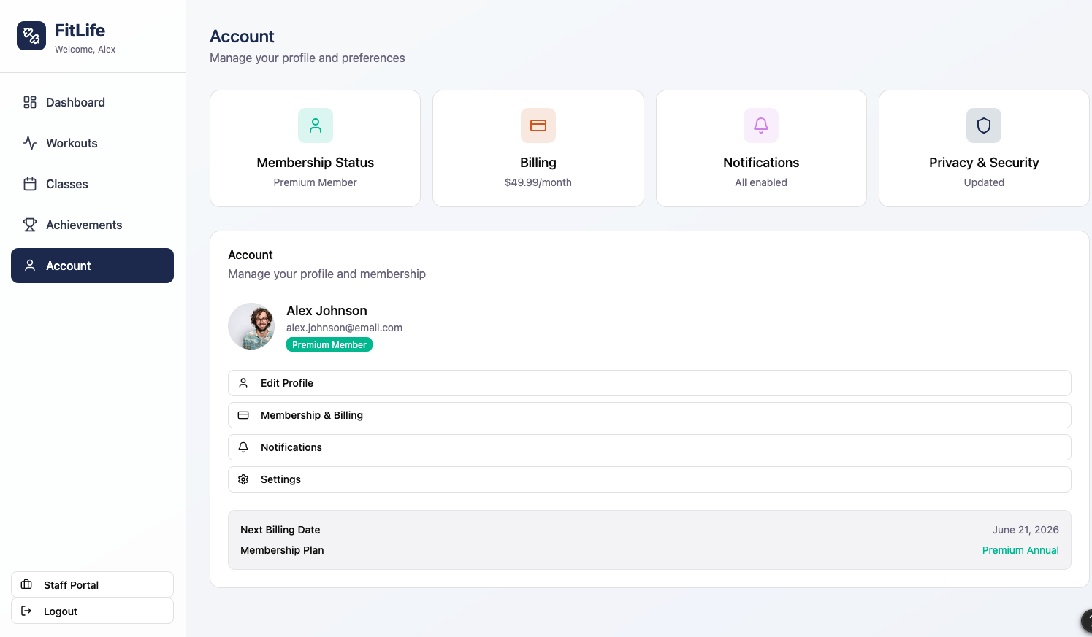
  - Dashboard empleado 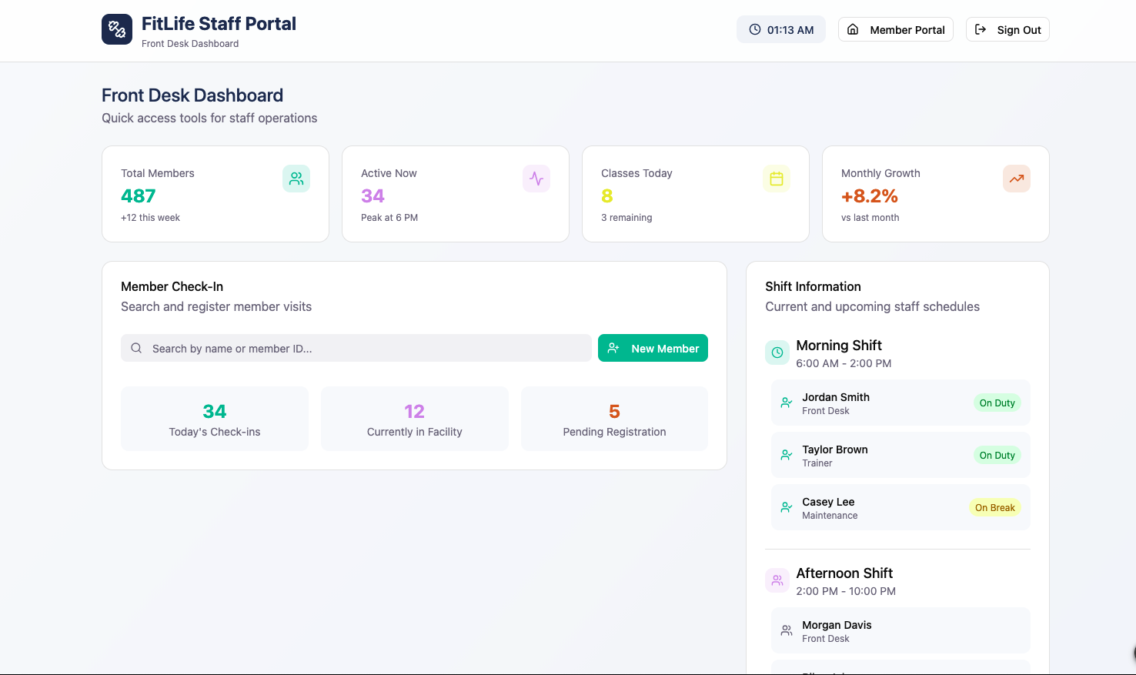

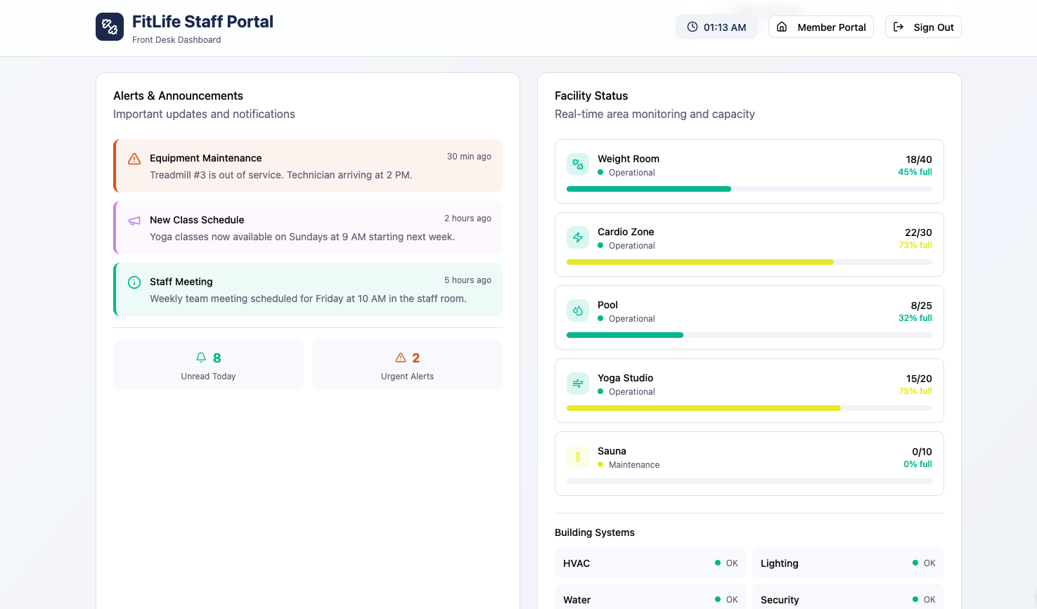

Business Model Processes:
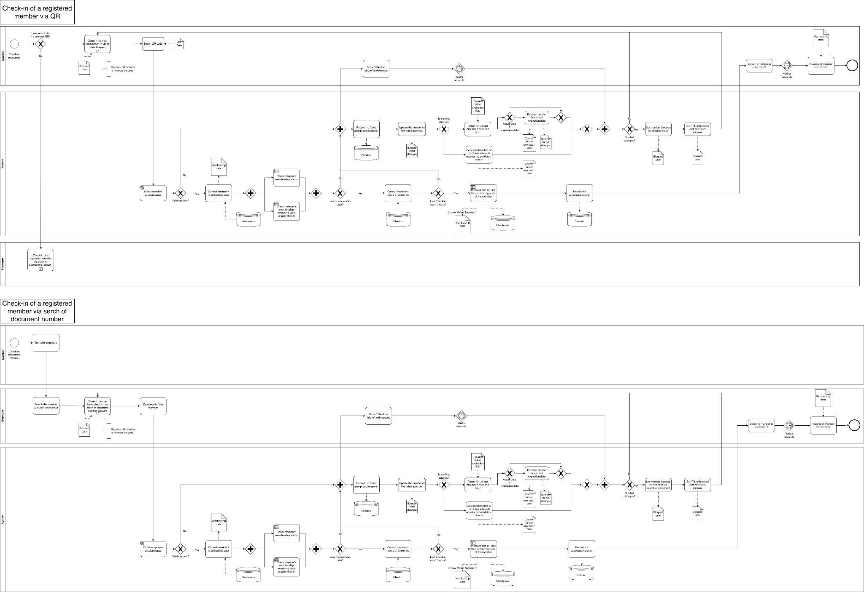

Architecture Diagram:
Architectural Style: Modular Monolith
GymFlow was designed following a Modular Monolith architectural style. This means the application is deployed as a single unit, but its internal codebase is organized into independent modules grouped by business domain: auth, members, checkin, membership, and reports. Each module owns its routing, business logic, data access, and validation schemas, communicating through defined interfaces rather than direct cross-module imports.
This style was chosen over the alternatives for three concrete reasons.
First, it fits the team size. With five developers and no predefined work division, the module-per-domain structure provides natural ownership boundaries. Each team member can take full responsibility for one module without interfering with others. The only shared integration point is main.py, which registers all routers in a single place.
Second, it matches the project scope. GymFlow is a gym access control system with well-defined and stable domains. Microservices would introduce significant operational overhead — independent deployments, service discovery, inter-service communication — that is not justified for a system of this scale. A well-structured monolith delivers the same separation of concerns at a fraction of the complexity.
T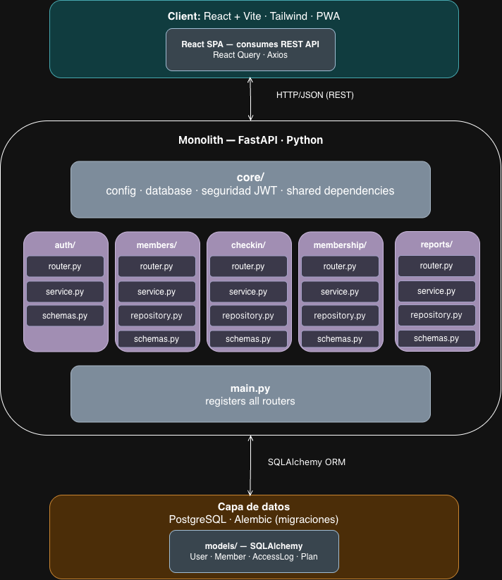

Diagrama UML de clases
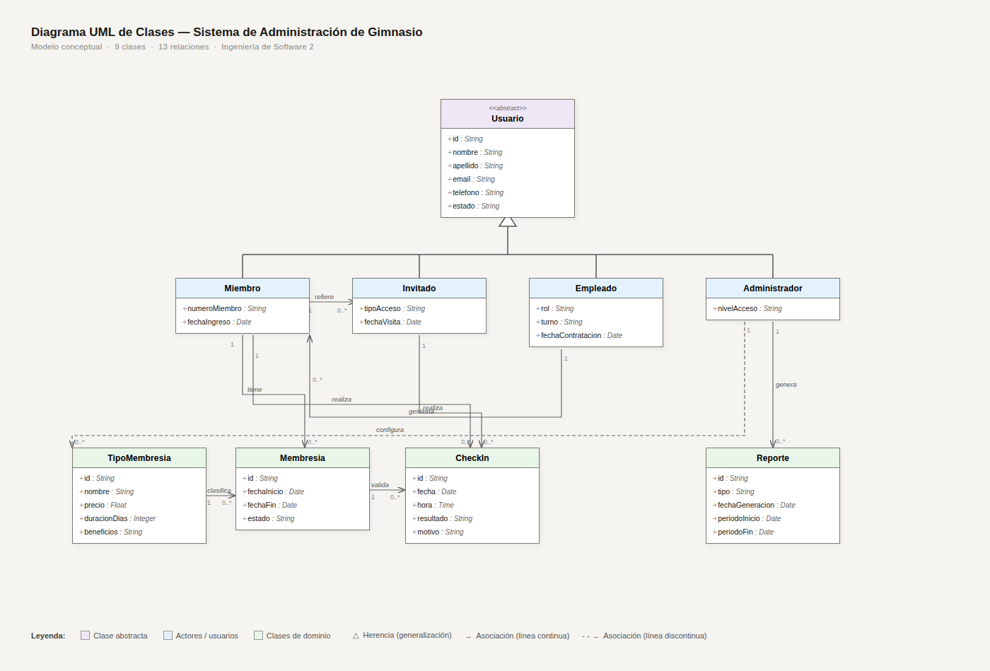

Relational Database Model
